**CSL 113 – COMPUTER PROGRAMMING  
  
BSCS 1A – Spring 2022**

**[VEHICLE DEALERSHIP]**



**Presented by: [Muhammad Umer Bahadur Khan (02-134221-007)**

**Submitted to: Ma’am Azeema Sadia**

**DEPARTMENT OF COMPUTER SCIENCE**

**BAHRIA UNIVERSITY, KARACHI CAMPUS**

**Tables of Contents**

**Introduction: *3***

**Objectives related to our project: *3***

**Scope of project: *4***

**METHODOLOGY: *5***

Here is a representation of our project through flowchart: 5

**WORKING OF THE PROJECT:** 6

Modules in Project: 6

**Code: *18***

**OUTPUT: *26***

**CONCLUSION: *29***

# 

# 

# Introduction:

***We are using Visual Studio C++ 2022 for our project. Basically this program is based on the car rent and buy system. The program will allow you to rent and buy your desired vehicle and will tell you the cost of the car you want to rent or buy. This program will also allow customer to rent a car for how much time. It helps the user to search specific cars for rent and buy. The vehicle dealership also helps the customer to makes the booking easy.***

# Objectives related to our project:

* ***To develop a web based system that will help manage the business of car rental and buying system.***
* ***To design a user friendly system that enables client check for availability of vehicle for rent and buy.***
* ***To design a system that shows the client the total amount to pay.***
* ***To design a system which manages all the details of the customer/client.***

# Scope of project:

***Vehicle dealership application, you can rent any car which is available at the dealership. “Exclusive Vehicle dealership” is a showroom where you can rent or buy you desired car as per your requirements/needs. This project will reduce human labor of a dealer at the showroom, and will allow customers to choose the vehicle they want. Any vehicle dealership company giving cars on rent or are selling their cars can use this program to make their work easier. Depends on the final outcome. A PC can be used to run the program and a command prompt can run the task. The use of internet technology has made it easy for the customers to rent or buy a car anytime.***

# METHODOLOGY:

## HERE IS A REPRESENTATION OF OUR PROJECT THROUGH FLOWCHART:

***Following is the entire description of our whole project through flowchart view.***

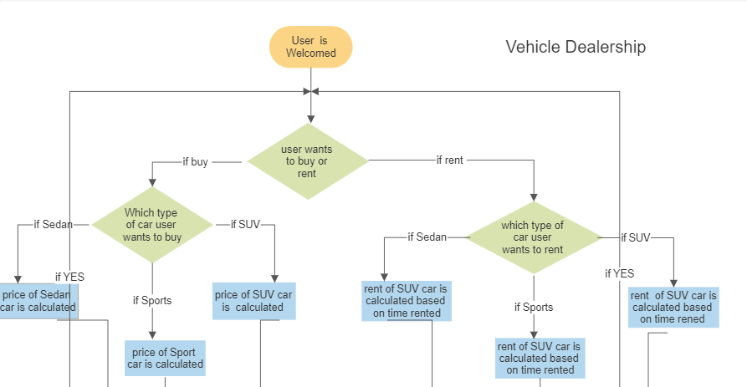

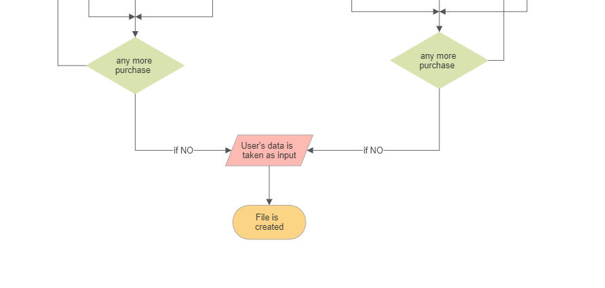

***In our project especially we used different research areas where we found a lot of information related to our project. We used different resources to do our work in a well-mannered and qualitative way. Vehicle dealership helps the customers to reserve their vehicles from anywhere at any time through different accounts, websites etc. We showed you all the information through some coding in C++, visual studio so you are enough capable to find out our performance. Vehicle Dealership also helps the customers to buy or rent their car on their own choice that which car they wants to buy or rent to their customer on daily basis and this is a very advanced way.***

# WORKING OF THE PROJECT:

***First the user will be welcomed to the dealership. After that he will have to choose to buy or rent a vehicle after that he will choose which kind of car he wants (sedan, SUV, etc.), after that he will choose the car he wants, if he wants to rent the car, he will be asked for how long he wants to rent the car like for 4 hours, 1 day or 1 week.***

## Modules in Project:

***The project has been divided into several modules. Following are the subjects the program has been divided into:***

## LIBRARIES:

### #include<iostream>:

***The <iostream> library is used for the input/output and enables us to use cin and cout function. Without this library the program will not print or save any variable or number given by the user.***

### #include<string>:

*The <string> library is used for the string names, passwords.*

### #include<fstream>:

*Basically the <fstream> library is used to open a file for reading or writing.*

### #includes<windows.h>:

*The <Windows.h> is a Windows-specific header file for the C and C++ programming languages which contains declarations for all of the functions in the Windows API, all the common macros used by Windows programmers, and all the data types used by the various functions and subsystems.*

***STRUCTURE:***

*Basically in this program we have used structure in order to declare several different data types in one place like string name, string address, int phone number and int CNIC.*

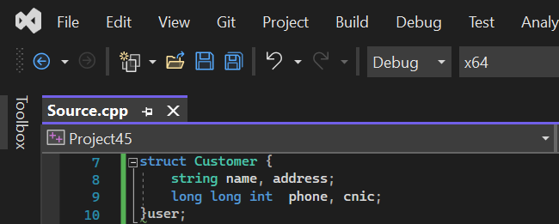

## FUNCTIONS:

### MAIN FUNCTION:

*This main function is basically used to call out the function of rent_buy().*

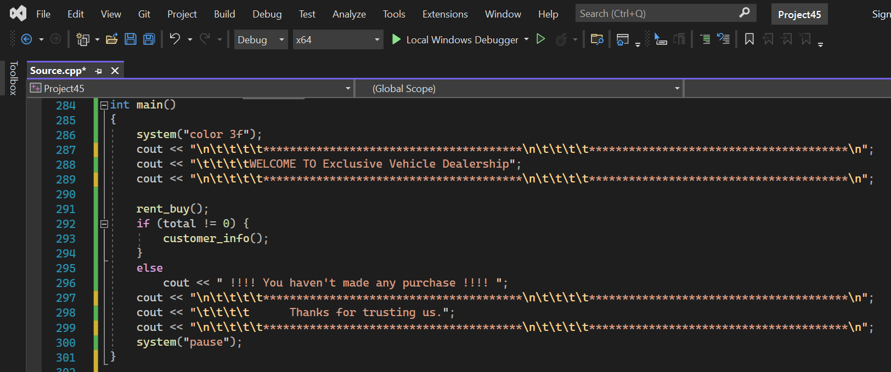

### RENT BUY FUNCTION:

*In this function we gave two choices to the user by using* ***if-else statement*** *that what he wants to select. If the user wants to a buy a car he should press 1 and if he wants to rent a car press 2.*

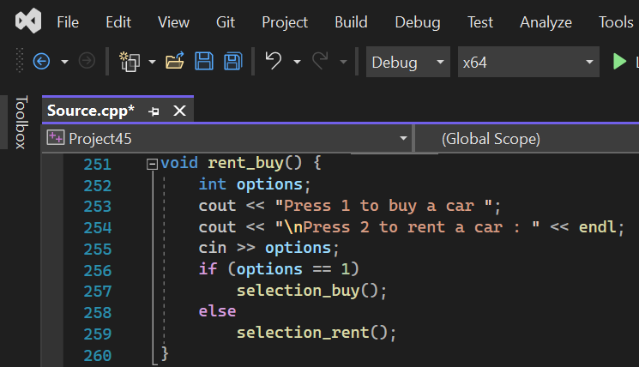

### SELECTION BUY FUNCTION:

*In the selection buy function the user will be asked that which type of car he wants to buy. The user will have 3 options that he wants to buy a* *SUV, Sedan or Sports. In this function we have used* ***switch statement*** *which allows the user which type of car we wants to buy.*

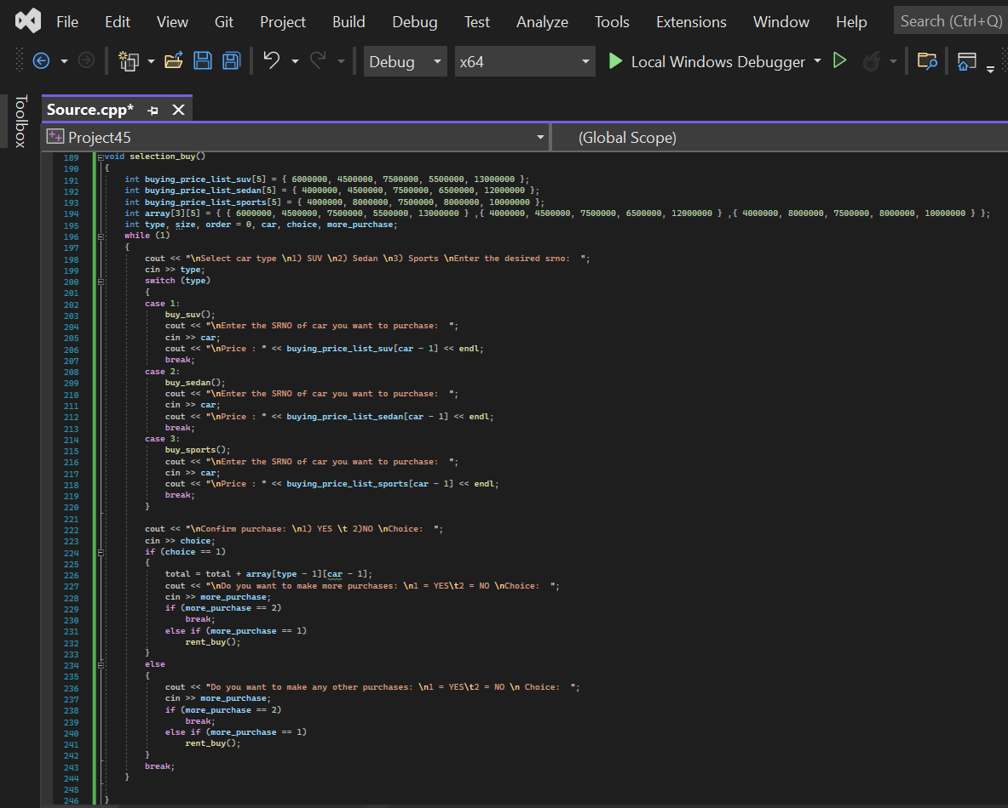

### BUY SUV FUNCTION:

*This function shows output to the user about different types of suv cars like Kia Sportage, Mitsubishi Pajero, Toyota RAV4, Hyundai Tucson and Lexus RX with their prices for buying .We printed name of cars along with their prices with the help of* ***for loop****.*

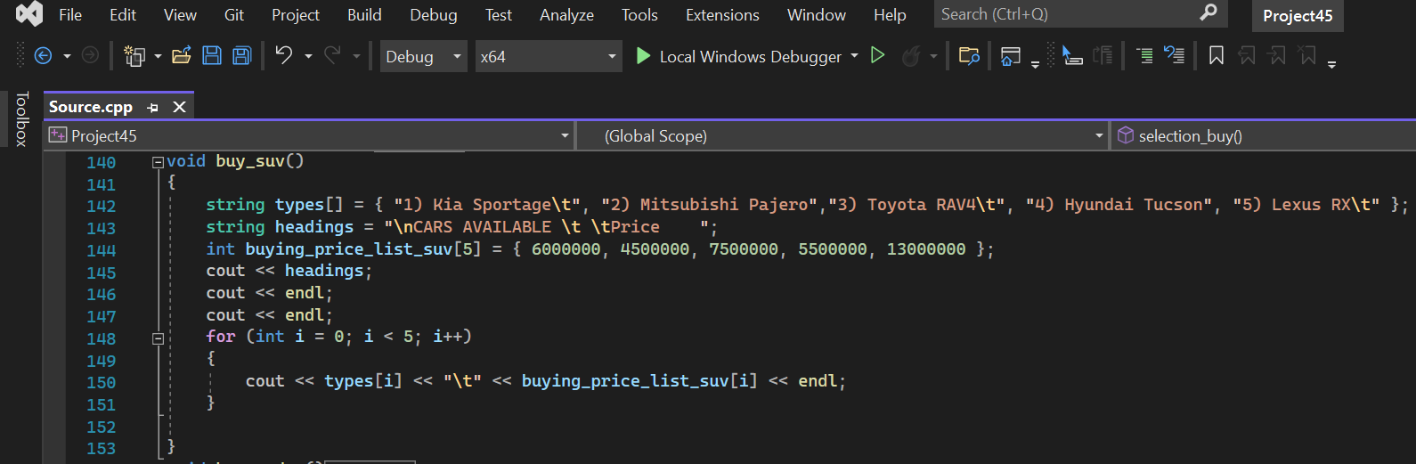

### BUY SEDAN FUNCTION:

*This function shows output to the user about different types of sedan cars like Toyota Corolla, Honda Civic, 2022 Audi A3, 2022 Honda Accord, 2022 Lexus ES with their prices for buying. We printed name of cars along with their prices with the help of* ***for loop****.*

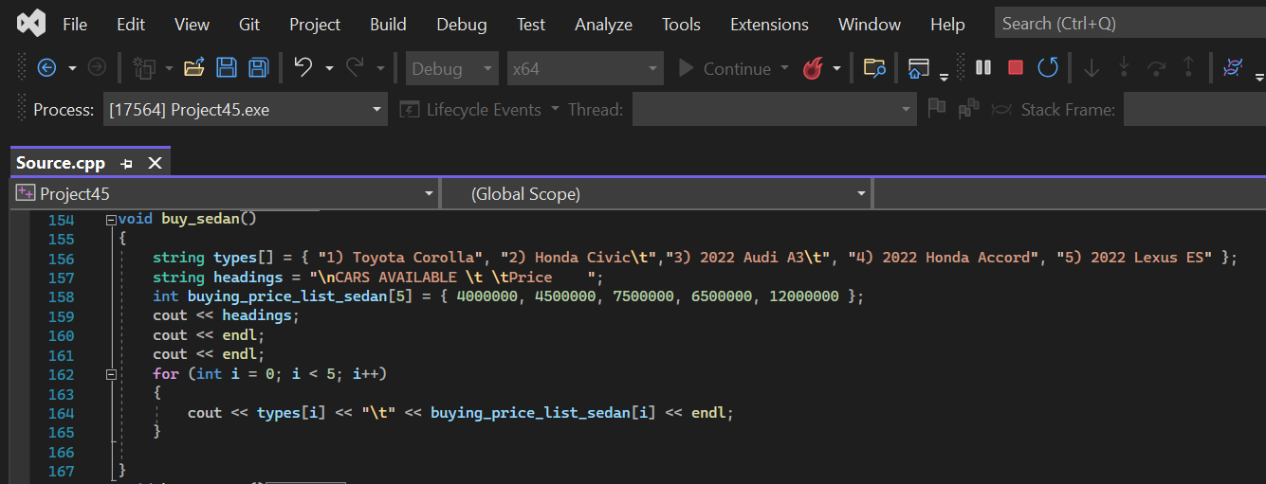

### BUY SPORTS FUNCTION:

*This function shows output to the user about different types of sports cars like* *Subaru BRZ, Toyota Supra, Ford Mustang, Nissan GT-R, Ferrari F8 with their prices for buying. We printed name of cars along with their prices with the help of* ***for loop****.*

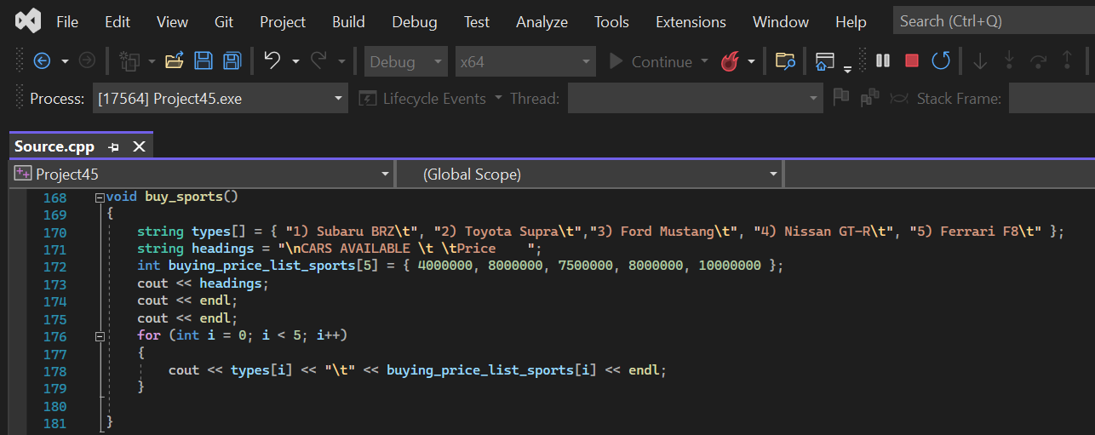

### SELECTION RENT FUNCTION:

*In the selection rent function the user will be asked that which type of car he wants to rent. The user will have 3 options that he wants to rent a* *SUV, Sedan or Sports. In this function we have used* ***switch statement*** *which allows the user which type of car we wants to rent.*

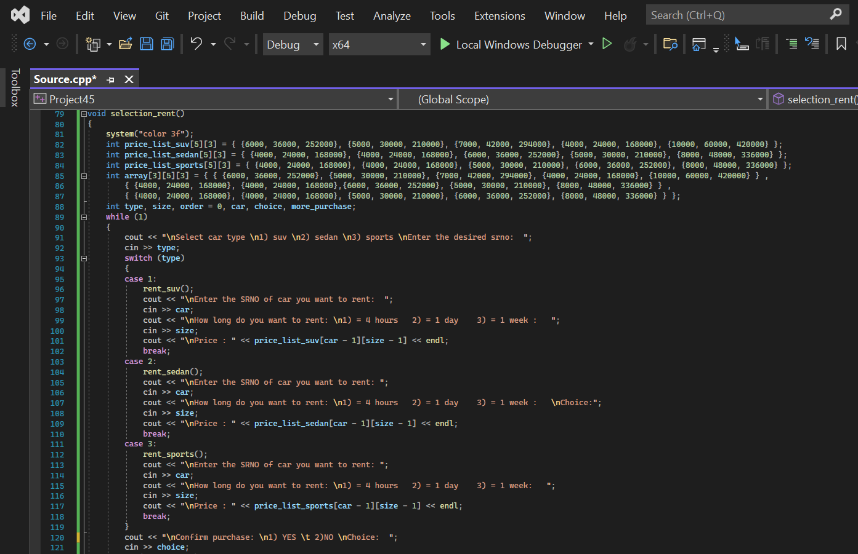

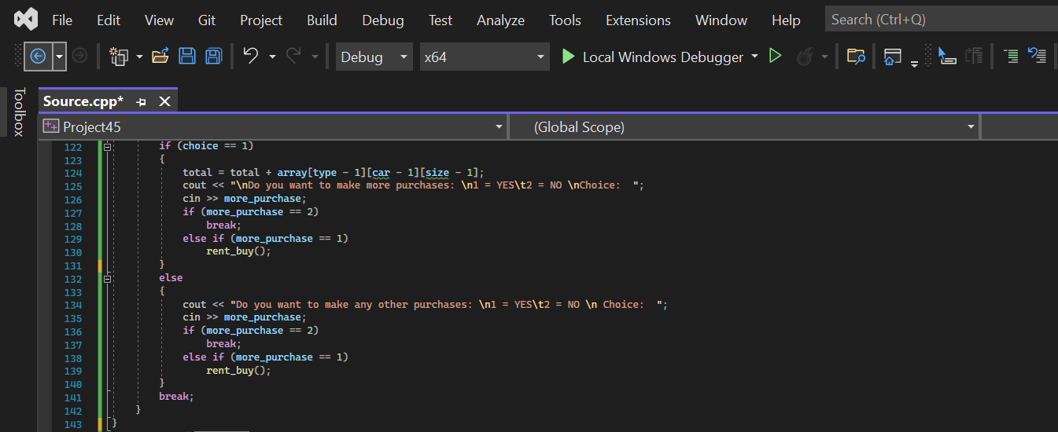

### RENT SUV FUNCTION:

*This function shows output to the user about different types of suv cars like Kia Sportage, Mitsubishi Pajero, Toyota RAV4, Hyundai Tucson and Lexus RX with their prices for renting .We printed name of cars along with their prices with the help of* ***for loop****. It also shows that for how much time you want to rent the car. It can be 4 hours or 1 day or 1 week.*

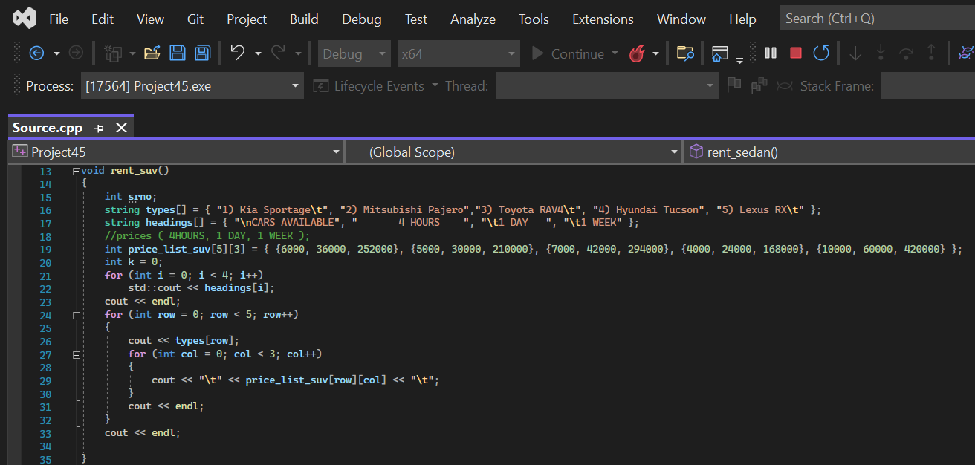

### RENT SEDAN FUNCTION:

*This function shows output to the user about different types of sedan cars like Toyota Corolla, Honda Civic, 2022 Audi A3, 2022 Honda Accord, 2022 Lexus ES with their prices for renting .We printed name of cars along with their prices with the help of* ***for loop****. It also shows that for how much time you want to rent the car. It can be 4 hours or 1 day or 1 week.*

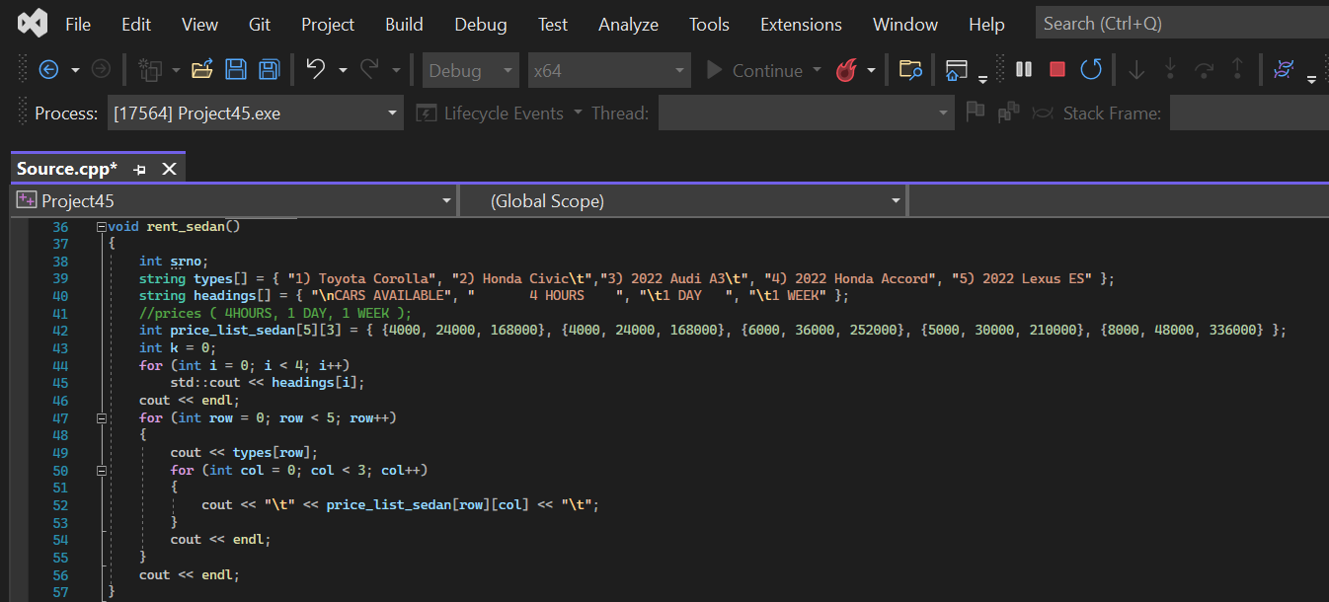

### RENT SPORTS FUNCTION:

*This function shows output to the user about different types of sports cars like* *Subaru BRZ, Toyota Supra, Ford Mustang, Nissan GT-R, Ferrari F8 with their prices for renting .We printed name of cars along with their prices with the help of* ***for loop****. It also shows that for how much time you want to rent the car. It can be 4 hours or 1 day or 1 week.*

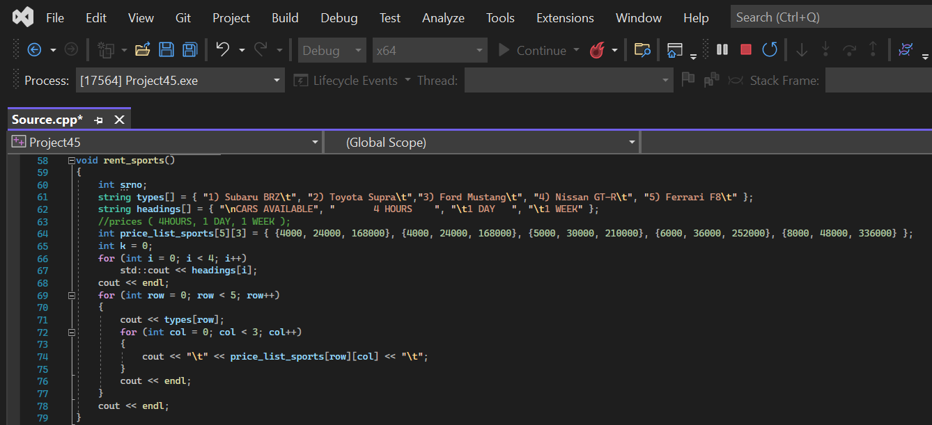

### CREATING FILE FUNCTION:

*Basically this function is used to store information of the user like Customer name, Customer’s CNIC number, Customer’s phone number, Customer’s address and Customer’s total bill in a text file named as information.txt with the help of* ***file handling****.*

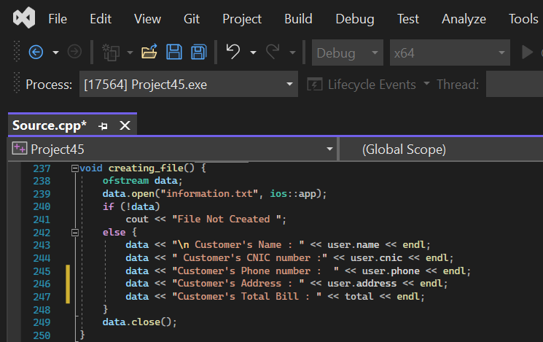

### CUSTOMER INFO FUNCTION:

*This function is used to takes information like full name, CNIC number, phone number and Address as an input from the user.*

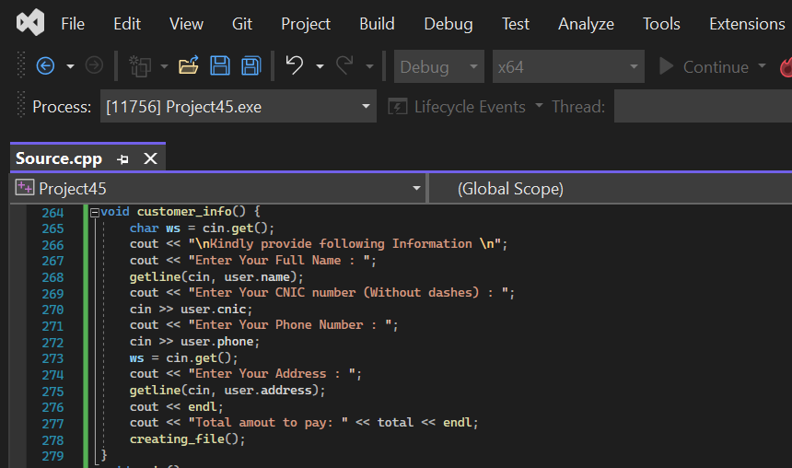

# Code:

#include<windows.h>

#include<iostream>

#include<string>

#include<fstream>

using namespace std;

void rent_buy();

struct Customer {

string name, address;

long long int phone, cnic;

}user;

int total = 0;

void rent_suv()

{

int srno;

string types[] = { "1) Kia Sportage\t", "2) Mitsubishi Pajero","3) Toyota RAV4\t", "4) Hyundai Tucson", "5) Lexus RX\t" };

string headings[] = { "\nCARS AVAILABLE", " 4 HOURS ", "\t1 DAY ", "\t1 WEEK" };

//prices ( 4HOURS, 1 DAY, 1 WEEK );

int price_list_suv[5][3] = { {6000, 36000, 252000}, {5000, 30000, 210000}, {7000, 42000, 294000}, {4000, 24000, 168000}, {10000, 60000, 420000} };

int k = 0;

for (int i = 0; i < 4; i++)

std::cout << headings[i];

cout << endl;

for (int row = 0; row < 5; row++)

{

cout << types[row];

for (int col = 0; col < 3; col++)

{

cout << "\t" << price_list_suv[row][col] << "\t";

}

cout << endl;

}

cout << endl;

}

void rent_sedan()

{

int srno;

string types[] = { "1) Toyota Corolla", "2) Honda Civic\t","3) 2022 Audi A3\t", "4) 2022 Honda Accord", "5) 2022 Lexus ES" };

string headings[] = { "\nCARS AVAILABLE", " 4 HOURS ", "\t1 DAY ", "\t1 WEEK" };

//prices ( 4HOURS, 1 DAY, 1 WEEK );

int price_list_sedan[5][3] = { {4000, 24000, 168000}, {4000, 24000, 168000}, {6000, 36000, 252000}, {5000, 30000, 210000}, {8000, 48000, 336000} };

int k = 0;

for (int i = 0; i < 4; i++)

std::cout << headings[i];

cout << endl;

for (int row = 0; row < 5; row++)

{

cout << types[row];

for (int col = 0; col < 3; col++)

{

cout << "\t" << price_list_sedan[row][col] << "\t";

}

cout << endl;

}

cout << endl;

}

void rent_sports()

{

int srno;

string types[] = { "1) Subaru BRZ\t", "2) Toyota Supra\t","3) Ford Mustang\t", "4) Nissan GT-R\t", "5) Ferrari F8\t" };

string headings[] = { "\nCARS AVAILABLE", " 4 HOURS ", "\t1 DAY ", "\t1 WEEK" };

//prices ( 4HOURS, 1 DAY, 1 WEEK );

int price_list_sports[5][3] = { {4000, 24000, 168000}, {4000, 24000, 168000}, {5000, 30000, 210000}, {6000, 36000, 252000}, {8000, 48000, 336000} };

int k = 0;

for (int i = 0; i < 4; i++)

std::cout << headings[i];

cout << endl;

for (int row = 0; row < 5; row++)

{

cout << types[row];

for (int col = 0; col < 3; col++)

{

cout << "\t" << price_list_sports[row][col] << "\t";

}

cout << endl;

}

cout << endl;

}

void selection_rent()

{

system("color 3f");

int price_list_suv[5][3] = { {6000, 36000, 252000}, {5000, 30000, 210000}, {7000, 42000, 294000}, {4000, 24000, 168000}, {10000, 60000, 420000} };

int price_list_sedan[5][3] = { {4000, 24000, 168000}, {4000, 24000, 168000}, {6000, 36000, 252000}, {5000, 30000, 210000}, {8000, 48000, 336000} };

int price_list_sports[5][3] = { {4000, 24000, 168000}, {4000, 24000, 168000}, {5000, 30000, 210000}, {6000, 36000, 252000}, {8000, 48000, 336000} };

int array[3][5][3] = { { {6000, 36000, 252000}, {5000, 30000, 210000}, {7000, 42000, 294000}, {4000, 24000, 168000}, {10000, 60000, 420000} } ,

{ {4000, 24000, 168000}, {4000, 24000, 168000},{6000, 36000, 252000}, {5000, 30000, 210000}, {8000, 48000, 336000} } ,

{ {4000, 24000, 168000}, {4000, 24000, 168000}, {5000, 30000, 210000}, {6000, 36000, 252000}, {8000, 48000, 336000} } };

int type, size, order = 0, car, choice, more_purchase;

while (1)

{

cout << "\nSelect car type \n1) suv \n2) sedan \n3) sports \nEnter the desired srno: ";

cin >> type;

switch (type)

{

case 1:

rent_suv();

cout << "\nEnter the SRNO of car you want to rent: ";

cin >> car;

cout << "\nHow long do you want to rent: \n1) = 4 hours 2) = 1 day 3) = 1 week : ";

cin >> size;

cout << "\nPrice : " << price_list_suv[car - 1][size - 1] << endl;

break;

case 2:

rent_sedan();

cout << "\nEnter the SRNO of car you want to rent: ";

cin >> car;

cout << "\nHow long do you want to rent: \n1) = 4 hours 2) = 1 day 3) = 1 week : \nChoice:";

cin >> size;

cout << "\nPrice : " << price_list_sedan[car - 1][size - 1] << endl;

break;

case 3:

rent_sports();

cout << "\nEnter the SRNO of car you want to rent: ";

cin >> car;

cout << "\nHow long do you want to rent: \n1) = 4 hours 2) = 1 day 3) = 1 week: ";

cin >> size;

cout << "\nPrice : " << price_list_sports[car - 1][size - 1] << endl;

break;

}

cout << "\nConfirm purchase: \n1) YES \t 2)NO \nChoice: ";

cin >> choice;

if (choice == 1)

{

total = total + array[type - 1][car - 1][size - 1];

cout << "\nDo you want to make more purchases: \n1 = YES\t2 = NO \nChoice: ";

cin >> more_purchase;

if (more_purchase == 2)

break;

else if (more_purchase == 1)

rent_buy();

}

else

{

cout << "Do you want to make any other purchases: \n1 = YES\t2 = NO \n Choice: ";

cin >> more_purchase;

if (more_purchase == 2)

break;

else if (more_purchase == 1)

rent_buy();

}

break;

}

}

void buy_suv()

{

string types[] = { "1) Kia Sportage\t", "2) Mitsubishi Pajero","3) Toyota RAV4\t", "4) Hyundai Tucson", "5) Lexus RX\t" };

string headings = "\nCARS AVAILABLE \t \tPrice ";

int buying_price_list_suv[5] = { 6000000, 4500000, 7500000, 5500000, 13000000 };

cout << headings;

cout << endl;

cout << endl;

for (int i = 0; i < 5; i++)

{

cout << types[i] << "\t" << buying_price_list_suv[i] << endl;

}

}

void buy_sedan()

{

string types[] = { "1) Toyota Corolla", "2) Honda Civic\t","3) 2022 Audi A3\t", "4) 2022 Honda Accord", "5) 2022 Lexus ES" };

string headings = "\nCARS AVAILABLE \t \tPrice ";

int buying_price_list_sedan[5] = { 4000000, 4500000, 7500000, 6500000, 12000000 };

cout << headings;

cout << endl;

cout << endl;

for (int i = 0; i < 5; i++)

{

cout << types[i] << "\t" << buying_price_list_sedan[i] << endl;

}

}

void buy_sports()

{

string types[] = { "1) Subaru BRZ\t", "2) Toyota Supra\t","3) Ford Mustang\t", "4) Nissan GT-R\t", "5) Ferrari F8\t" };

string headings = "\nCARS AVAILABLE \t \tPrice ";

int buying_price_list_sports[5] = { 4000000, 8000000, 7500000, 8000000, 10000000 };

cout << headings;

cout << endl;

cout << endl;

for (int i = 0; i < 5; i++)

{

cout << types[i] << "\t" << buying_price_list_sports[i] << endl;

}

}

void selection_buy()

{

int buying_price_list_suv[5] = { 6000000, 4500000, 7500000, 5500000, 13000000 };

int buying_price_list_sedan[5] = { 4000000, 4500000, 7500000, 6500000, 12000000 };

int buying_price_list_sports[5] = { 4000000, 8000000, 7500000, 8000000, 10000000 };

int array[3][5] = { { 6000000, 4500000, 7500000, 5500000, 13000000 } ,{ 4000000, 4500000, 7500000, 6500000, 12000000 } ,{ 4000000, 8000000, 7500000, 8000000, 10000000 } };

int type, size, order = 0, car, choice, more_purchase;

while (1)

{

cout << "\nSelect car type \n1) SUV \n2) Sedan \n3) Sports \nEnter the desired srno: ";

cin >> type;

switch (type)

{

case 1:

buy_suv();

cout << "\nEnter the SRNO of car you want to purchase: ";

cin >> car;

cout << "\nPrice : " << buying_price_list_suv[car - 1] << endl;

break;

case 2:

buy_sedan();

cout << "\nEnter the SRNO of car you want to purchase: ";

cin >> car;

cout << "\nPrice : " << buying_price_list_sedan[car - 1] << endl;

break;

case 3:

buy_sports();

cout << "\nEnter the SRNO of car you want to purchase: ";

cin >> car;

cout << "\nPrice : " << buying_price_list_sports[car - 1] << endl;

break;

}

cout << "\nConfirm purchase: \n1) YES \t 2)NO \nChoice: ";

cin >> choice;

if (choice == 1)

{

total = total + array[type - 1][car - 1];

cout << "\nDo you want to make more purchases: \n1 = YES\t2 = NO \nChoice: ";

cin >> more_purchase;

if (more_purchase == 2)

break;

else if (more_purchase == 1)

rent_buy();

}

else

{

cout << "Do you want to make any other purchases: \n1 = YES\t2 = NO \n Choice: ";

cin >> more_purchase;

if (more_purchase == 2)

break;

else if (more_purchase == 1)

rent_buy();

}

break;

}

}

void creating_file() {

ofstream data;

data.open("information.txt", ios::app);

if (!data)

cout << "File Not Created ";

else {

data << "\nCustomer's Name : " << user.name << endl;

data << "Customer's CNIC number :" << user.cnic << endl;

data << "Customer's Phone number : " << user.phone << endl;

data << "Customer's Address : " << user.address << endl;

data << "Customer's Total Bill : " << total << endl;

}

data.close();

}

void rent_buy() {

int options;

cout << "\nPress 1 to buy a car ";

cout << "\nPress 2 to rent a car : " << endl;

cin >> options;

if (options == 1)

selection_buy();

else

selection_rent();

}

void customer_info() {

char ws = cin.get();

cout << "\nKindly provide following Information \n";

cout << "Enter Your Full Name : ";

getline(cin, user.name);

cout << "Enter Your CNIC number (Without dashes) : ";

cin >> user.cnic;

cout << "Enter Your Phone Number : ";

cin >> user.phone;

ws = cin.get();

cout << "Enter Your Address : ";

getline(cin, user.address);

cout << endl;

cout << "Total amout to pay: " << total << endl;

creating_file();

}

int main()

{

system("color 3f");

cout << "\n\t\t\t\t***************************************\n\t\t\t\t***************************************\n";

cout << "\t\t\t\tWELCOME TO Exclusive Vehicle Dealership";

cout << "\n\t\t\t\t***************************************\n\t\t\t\t***************************************\n";

rent_buy();

if (total != 0) {

customer_info();

}

else

cout << " !!!! You haven't made any purchase !!!! ";

cout << "\n\t\t\t\t***************************************\n\t\t\t\t***************************************\n";

cout << "\t\t\t\t Thanks for trusting us.";

cout << "\n\t\t\t\t***************************************\n\t\t\t\t***************************************\n";

system("pause");

}

# OUTPUT:

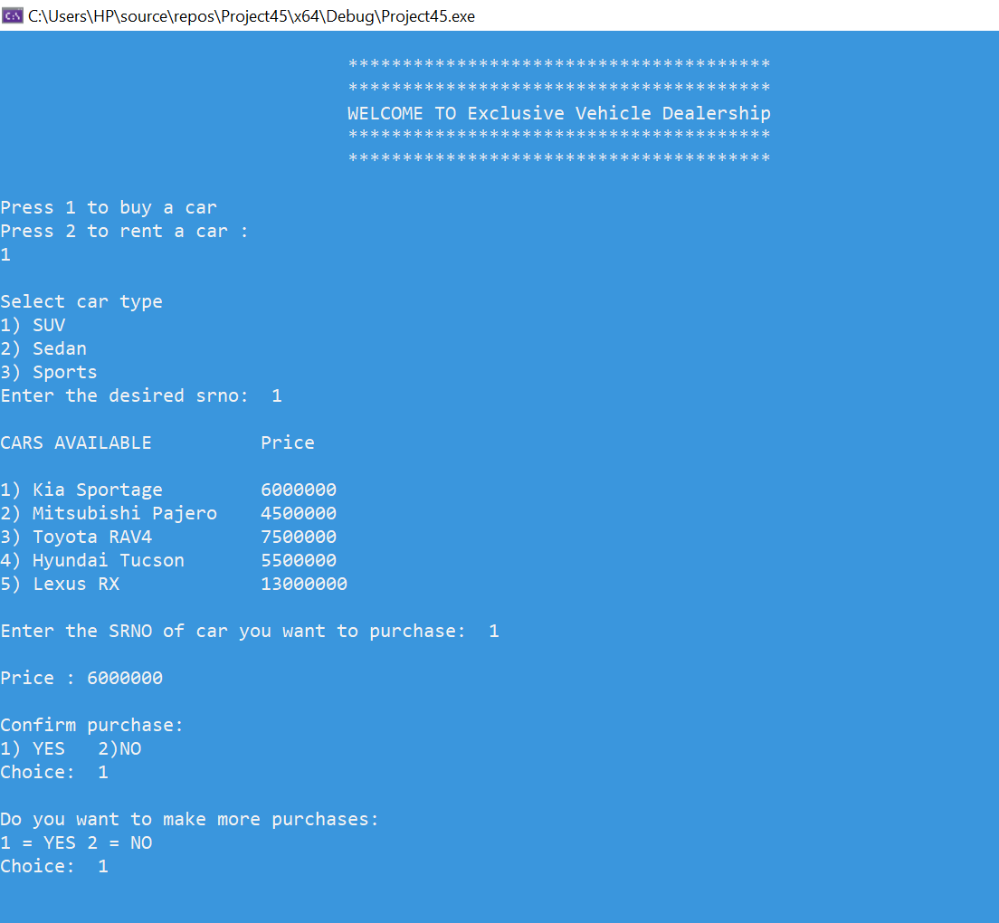

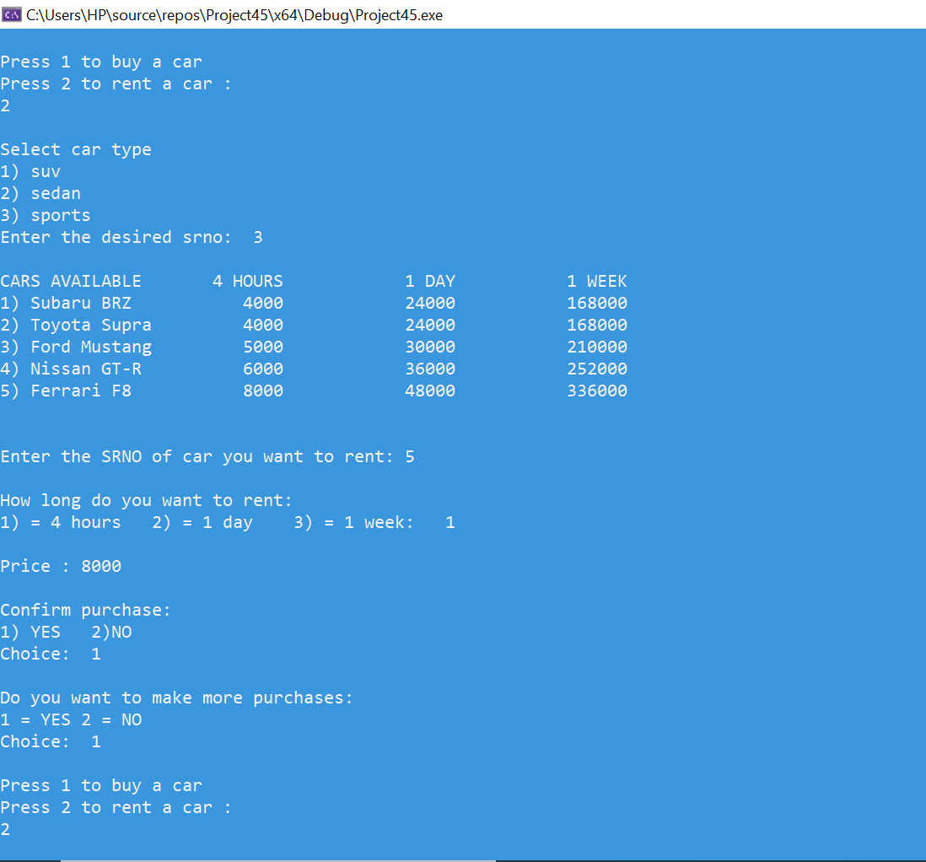

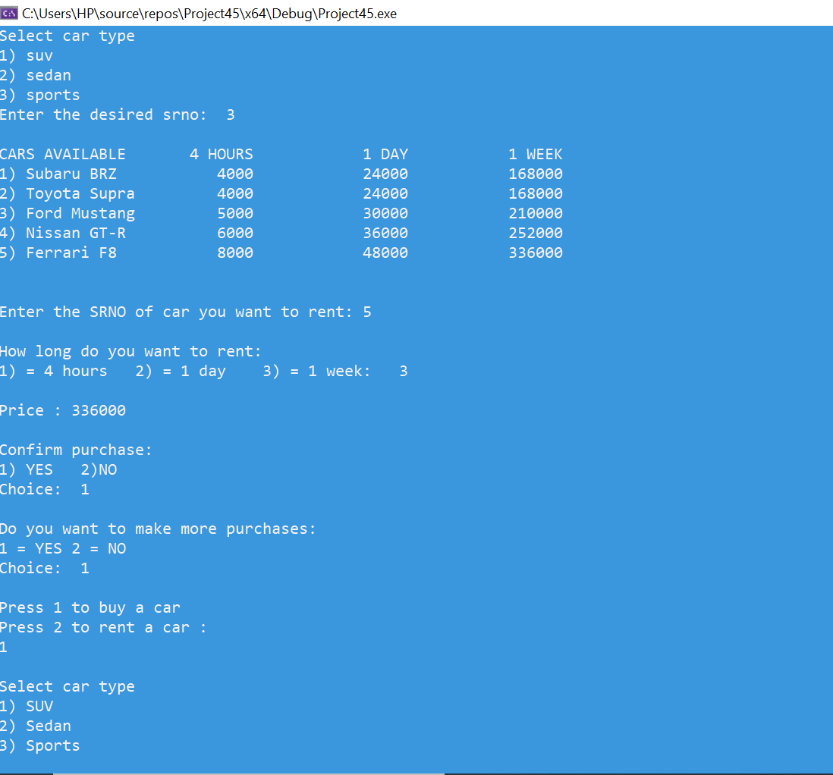

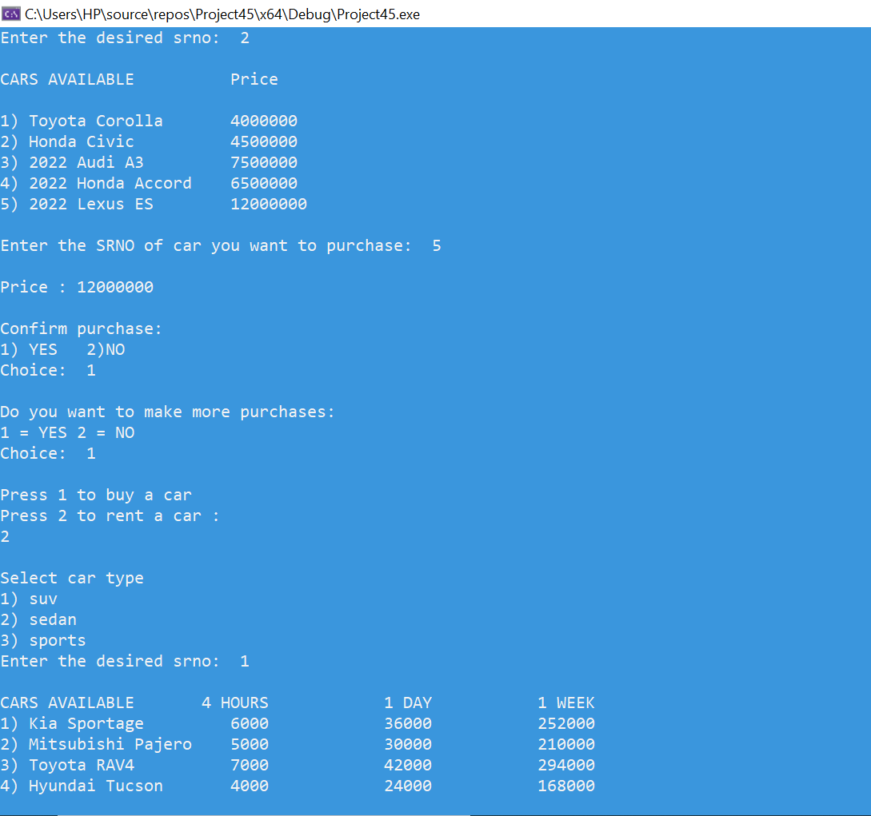

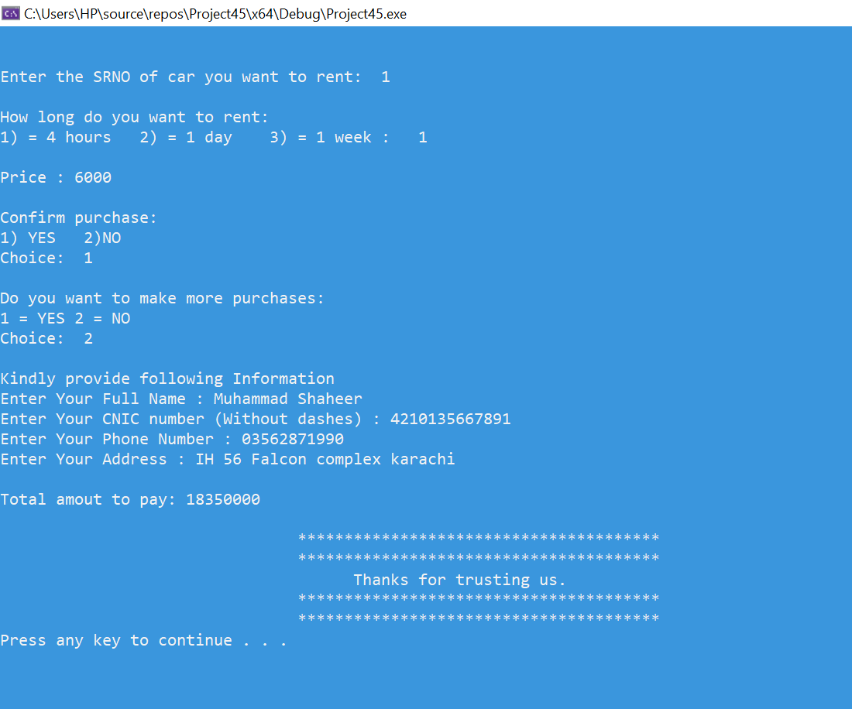

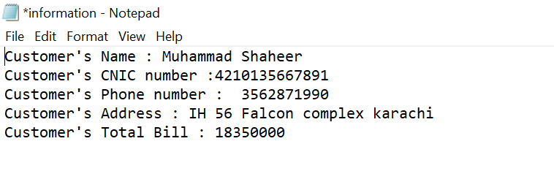

# CONCLUSION:

*To conclude, it was important to us that we learned how to design a program architecture, convert real-life situations into efficient code, and how you can write readable and understandable code that is both time- and memory-efficient. Customers will be able to reserve or buy their vehicles from anywhere with help of vehicle dealership.* *Car Rental System has offered an advantage to both vehicle dealership as well as vehicle dealership owner to efficiently and effectively manage the business and satisfies user’s need.*